**LEBANESE AMERICAN UNIVERSITY**

**USAID – HIGHER EDUCATION SCHOLARSHIP PROGRAM**

**HES - Volunteering Program Verification Form**

This form is to be used to document volunteering hours. If a student volunteers for multiple organizations, a separate form must be used for each organization. **This form must be turned in by the 28th of each month, the latest.**

I certify that the scholar Dana Nasr completed a total of 24 hours of service at Life Sculptor.

The hours were completed hours as per the below:

Hours # 0 (date) _30/09 – 5/10_ (initials of supervisor) __A.K.___

Hours # 8 (date) _7/10 – 11/10_ (initials of supervisor) __A.K.___

Hours # 8 date) _14/10 – 18/10 (initials of supervisor) __A.K.___

Hours # 8 date) _21/10 -25/10 (initials of supervisor) __A.K.___

Brief description of the activities the scholar performed or participated in:

For this month, I have contributed to the improvement of the organizational work by reporting underlying concerns and suggesting feasible fixes to the said problems in a well-detailed report. I have also attended a management meeting to tackle to progress of the work of the organization in light of the unfortunate circumstances the country is experiencing. Additionally, I have partaken in another organizational meeting to discuss the launch of a new club at Life Sculptor, giving my input and suggesting ideas to implement. Finally, I have followed up with the heads and presidents of the clubs and departments after resuming the activity in the organization, ensuring work gets back on track and making sure to resolve any issues they might face.

Written feedback about the scholar’s performance:

Dana’s contribution to organizational improvement, meeting participation, and follow-up with department heads highlights her leadership, problem-solving, and communication skills.

Please rate the overall performance of the scholar at your organization:

|  |  |  |  |
| --- | --- | --- | --- |
|  | Mastery (5) | Proficient (3) | Emerging (1) |
| **Problem solver** | X |  |  |
| **Engaged & Committed** | X |  |  |
| **Open-minded & multicultural** | X |  |  |

Signature

& stamp

__________________________

_

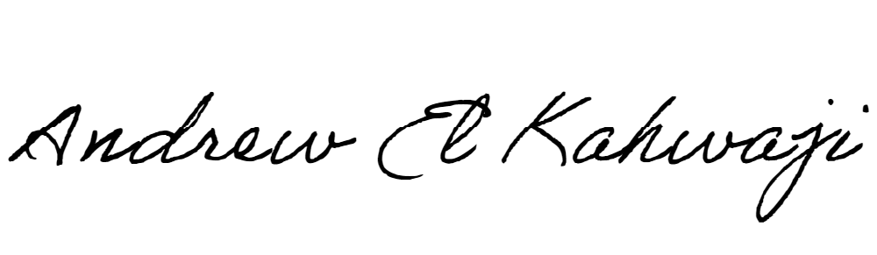

Printed Name _Andrew El Kahwaji_

Date __26/10/2024___

Email __andrew.lifesculptor.coo@gmail.com __

Phone __+961 71 914 378__

**LEBANESE AMERICAN UNIVERSITY**

**USAID – HIGHER EDUCATION SCHOLARSHIP PROGRAM**

